|  |  |
| --- | --- |
|  | Outgroup |
|  | Myosin-binding proteins |
|  | Myosin heavy chain |
|  | Myosin light chain |
|  | Unconventional myosin |
|  | Portable actin motors with kinase activity |
|  | Proteins without a clear category |

Supplemental Information

**Supplemental Table 1**: Table outlining the categories of proteins used in this analysis. The colors are used in tables and figures to help visualize the relationship between the proteins. The outgroup is like the proteins being analyzed but is different enough that it wouldn’t be considered as part of the analysis. The purpose of an outgroup is to root an unrooted phylogenetic tree. Myosin binding proteins category are myosin proteins that’re thick filament associated proteins in the crossbridge region of muscle bands5. The category myosin heavy chain indicates cellular myosin that are involved with cell shape, cytokinesis, and specialized functions5. Myosin light chains is the group of myosin proteins that are regulatory light chains that may or may not be calcium binding5. The unconventional myosin category contains myosins involved in intracellular movements5. Portable actin motors with kinase activity are myosin proteins that appears to play a role in vision and/or hearing5. The final category, proteins without a clear category, are proteins that don’t have clear initial relation with the other subgroups.

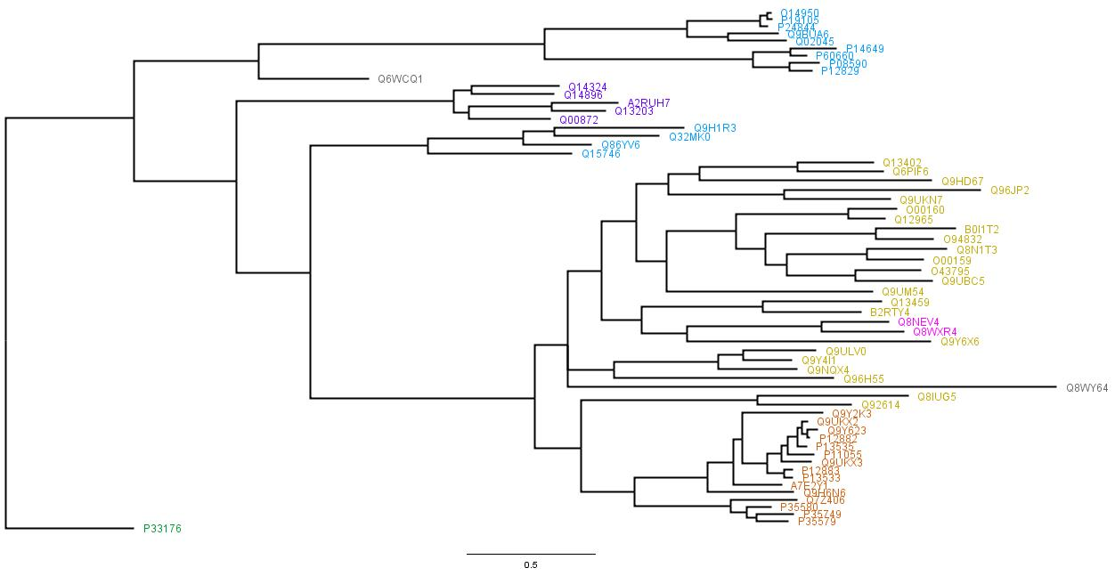

**Supplemental Figure 1**: Raw consensus tree rooted by P33176. All the colors correspond with the groups shown in Supplemental Table 1. Look at Supplemental Table 2 for identifying the taxa labels in this figure to the protein names.

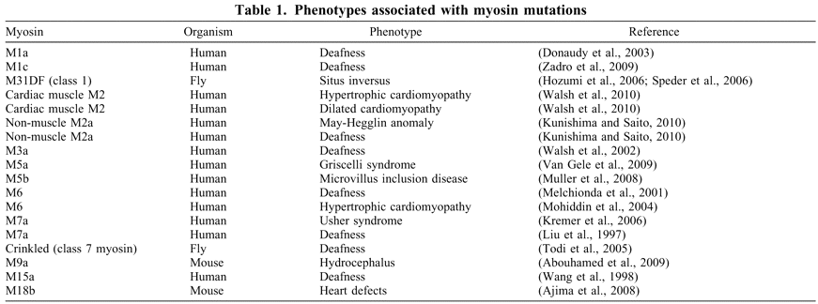

**Supplemental Table 2**: Phenotypes associated with myosin mutations. This table is from *The Myosin Superfamily at a Glance* article by M. Amanda Hartman and James A. Spudich. The original journal article was published in the Journal of Cell Science.

|  |  |  |  |  |
| --- | --- | --- | --- | --- |
| **Entry** | **Entry name** | **Protein names** | **Gene names** | **Length** |
| P33176 | KINH_HUMAN | Kinesin-1 heavy chain | KIF5B KNS KNS1 | 963 |
| Q6WCQ1 | MPRIP_HUMAN | Myosin phosphatase Rho-interacting protein | MPRIP KIAA0864 MRIP RHOIP3 | 1025 |
| Q00872 | MYPC1_HUMAN | Myosin-binding protein C, slow-type | MYBPC1 MYBPCS | 1141 |
| Q14324 | MYPC2_HUMAN | Myosin-binding protein C, fast-type | MYBPC2 MYBPCF | 1141 |
| Q14896 | MYPC3_HUMAN | Myosin-binding protein C, cardiac-type | MYBPC3 | 1274 |
| Q13203 | MYBPH_HUMAN | Myosin-binding protein H | MYBPH | 477 |
| A2RUH7 | MBPHL_HUMAN | Myosin-binding protein H-like | MYBPHL | 354 |
| P12882 | MYH1_HUMAN | Myosin-1 | MYH1 | 1939 |
| P35580 | MYH10_HUMAN | Myosin-10 | MYH10 | 1976 |
| P35749 | MYH11_HUMAN | Myosin-11 | MYH11 KIAA0866 | 1972 |
| Q9UKX3 | MYH13_HUMAN | Myosin-13 | MYH13 | 1938 |
| Q7Z406 | MYH14_HUMAN | Myosin-14 | MYH14 KIAA2034 FP17425 | 1995 |
| Q9Y2K3 | MYH15_HUMAN | Myosin-15 | MYH15 KIAA1000 | 1946 |
| Q9H6N6 | MYH16_HUMAN | Putative uncharacterized protein MYH16 | MYH16 MYH5 | 1097 |
| Q9UKX2 | MYH2_HUMAN | Myosin-2 | MYH2 MYHSA2 | 1941 |
| P11055 | MYH3_HUMAN | Myosin-3 | MYH3 | 1940 |
| Q9Y623 | MYH4_HUMAN | Myosin-4 | MYH4 | 1939 |
| P13533 | MYH6_HUMAN | Myosin-6 | MYH6 MYHCA | 1939 |
| P12883 | MYH7_HUMAN | Myosin-7 | MYH7 MYHCB | 1935 |
| A7E2Y1 | MYH7B_HUMAN | Myosin-7B | MYH7B KIAA1512 | 1983 |
| P13535 | MYH8_HUMAN | Myosin-8 | MYH8 | 1937 |
| P35579 | MYH9_HUMAN | Myosin-9 | MYH9 | 1960 |
| Q9BUA6 | MYL10_HUMAN | Myosin regulatory light chain 10 | MYL10 MYLC2PL PLRLC | 226 |
| P19105 | ML12A_HUMAN | Myosin regulatory light chain 12A | MYL12A MLCB MRLC3 RLC | 171 |
| O14950 | ML12B_HUMAN | Myosin regulatory light chain 12B | MYL12B MRLC2 MYLC2B | 172 |
| P08590 | MYL3_HUMAN | Myosin light chain 3 | MYL3 | 195 |
| P12829 | MYL4_HUMAN | Myosin light chain 4 | MYL4 MLC1 PRO1957 | 197 |
| Q02045 | MYL5_HUMAN | Myosin light chain 5 | MYL5 | 173 |
| P60660 | MYL6_HUMAN | Myosin light polypeptide 6 | MYL6 | 151 |
| P14649 | MYL6B_HUMAN | Myosin light chain 6B | MYL6B MLC1SA | 208 |
| P24844 | MYL9_HUMAN | Myosin regulatory light polypeptide 9 | MYL9 MLC2 MRLC1 MYRL2 | 172 |
| Q8WY64 | MYLIP_HUMAN | E3 ubiquitin-protein ligase MYLIP | MYLIP BZF1 IDOL BM-023 PP5242 | 445 |
| Q15746 | MYLK_HUMAN | Myosin light chain kinase, smooth muscle | MYLK MLCK MLCK1 MYLK1 | 1914 |
| Q9H1R3 | MYLK2_HUMAN | Myosin light chain kinase 2, skeletal/cardiac muscle | MYLK2 | 596 |
| Q32MK0 | MYLK3_HUMAN | Myosin light chain kinase 3 | MYLK3 MLCK | 819 |
| Q86YV6 | MYLK4_HUMAN | Myosin light chain kinase family member 4 | MYLK4 SGK085 | 388 |
| Q9HD67 | MYO10_HUMAN | Unconventional myosin-X | MYO10 KIAA0799 | 2058 |
| Q9UKN7 | MYO15_HUMAN | Unconventional myosin-XV | MYO15A MYO15 | 3530 |
| Q96JP2 | MY15B_HUMAN | Unconventional myosin-XVB | MYO15B KIAA1783 MYO15BP | 1530 |
| Q9Y6X6 | MYO16_HUMAN | Unconventional myosin-XVI | MYO16 KIAA0865 MYO16B NYAP3 | 1858 |
| Q92614 | MY18A_HUMAN | Unconventional myosin-XVIIIa | MYO18A CD245 KIAA0216 MYSPDZ | 2054 |
| Q8IUG5 | MY18B_HUMAN | Unconventional myosin-XVIIIb | MYO18B | 2567 |
| Q96H55 | MYO19_HUMAN | Unconventional myosin-XIX | MYO19 MYOHD1 | 970 |
| Q9UBC5 | MYO1A_HUMAN | Unconventional myosin-Ia | MYO1A MYHL | 1043 |
| O43795 | MYO1B_HUMAN | Unconventional myosin-Ib | MYO1B | 1136 |
| O00159 | MYO1C_HUMAN | Unconventional myosin-Ic | MYO1C | 1063 |
| O94832 | MYO1D_HUMAN | Unconventional myosin-Id | MYO1D KIAA0727 | 1006 |
| Q12965 | MYO1E_HUMAN | Unconventional myosin-Ie | MYO1E MYO1C | 1108 |
| O00160 | MYO1F_HUMAN | Unconventional myosin-If | MYO1F | 1098 |
| B0I1T2 | MYO1G_HUMAN | Unconventional myosin-Ig | MYO1G HA2 | 1018 |
| Q8N1T3 | MYO1H_HUMAN | Unconventional myosin-Ih | MYO1H | 1032 |
| Q8NEV4 | MYO3A_HUMAN | Myosin-IIIa | MYO3A | 1616 |
| Q8WXR4 | MYO3B_HUMAN | Myosin-IIIb | MYO3B | 1341 |
| Q9Y4I1 | MYO5A_HUMAN | Unconventional myosin-Va | MYO5A MYH12 | 1855 |
| Q9ULV0 | MYO5B_HUMAN | Unconventional myosin-Vb | MYO5B KIAA1119 | 1848 |
| Q9NQX4 | MYO5C_HUMAN | Unconventional myosin-Vc | MYO5C | 1742 |
| Q9UM54 | MYO6_HUMAN | Unconventional myosin-VI | MYO6 KIAA0389 | 1294 |
| Q13402 | MYO7A_HUMAN | Unconventional myosin-VIIa | MYO7A USH1B | 2215 |
| Q6PIF6 | MYO7B_HUMAN | Unconventional myosin-VIIb | MYO7B | 2116 |
| B2RTY4 | MYO9A_HUMAN | Unconventional myosin-IXa | MYO9A MYR7 | 2548 |
| Q13459 | MYO9B_HUMAN | Unconventional myosin-IXb | MYO9B MYR5 | 2157 |

**Supplemental Table 2:** Table displays the entry number (same identifier used in the analysis), entry name, protein name, gene name, and the length of proteins analyzed. There are 60 myosin proteins, and one kinesin protein. The colors in the table indicate different groups within the proteins. Green = outgroup. Purple = binding proteins. Orange = heavy chain. Blue = light chain. Yellow = unc proteins. Pink = portable actin motor. Grey = proteins that don’t clearly fit into other groups. For further information regarding their function and other properties, visit [UnitProtKB](https://www.uniprot.org/uniprot/?query=yourlist%3AM201904278471C63D39733769F8E060B506551E120A1508K&sort=genes&desc=no).